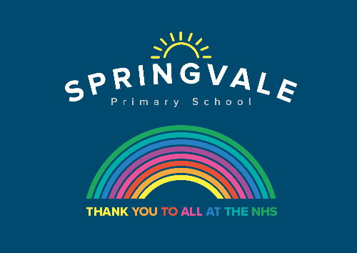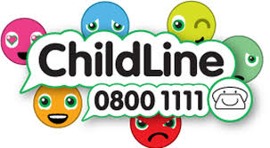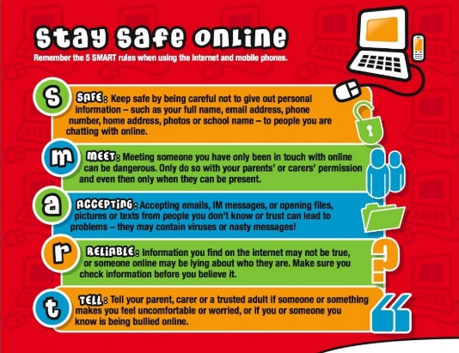

|  |  |
| --- | --- |
| **W/C 13.07.2020: Learning Project - Space** | |
| **Age Range:** EYFS  FS2 The Curious Cubs | |
| **Weekly Reading Tasks** | **Weekly Phonics Tasks** |
| **Monday-** Visit [Storytime from Space](https://storytimefromspace.com/a-moon-of-my-own-2/) and let your child listen to the Story Time video of A Moon of My Own. | Mrs Slack/Mrs Gale/Mrs Evans  Revise/Re-cap Set 2 Sounds, (see Speed Sounds Set 2 mat attached).  Play the online game ‘[Picnic on Pluto’](https://www.phonicsplay.co.uk/PicnicOnPluto.html) to revise these sounds.  Mrs Cliffe/Mrs Honey and Mrs Parr  Play Splat the Letter to re-cap: ch sh th ng nk ay ee igh  Google Read Write Inc Set 2 sound ow to find a video introducing the new sound. |
| **Tuesday-** Listen to a space themed online story, [Aliens Love Underpants](https://safeyoutube.net/w/ZYg6), [Roaring Rockets](https://safeyoutube.net/w/mZg6) and [Whatever Next?](https://safeyoutube.net/w/tZg6) Which is your favourite? Why? | **Tuesday-** Make some real and nonsense words for Obb and Bob, (Obb likes nonsense words and Bob likes real words. Write different sounds on paper (re-use the sounds from last week). Put the sounds together to make different words e.g ch-u-g (chug), v-ee (vee) s-igh (sigh) z-ay (zay) |
| **Wednesday-** Using the space stories as a starting point, ask your child to make up their own story about space. It could use the same characters or settings as one of the stories you have shared together. | **Wednesday-** Play Washing Line Phonics- Peg along a washing line, or clothes airer, a number of different readable words. Write each word on a piece of card, muddle them up and ask your child to re-arrange them so that they make sense.  Obb and Bob jump on the moon  Obb and Bob jump in the snow. |
| **Thursday-** Ask your child to draw a picture of one of the events from their made up space story. Can they explain what’s happening in the picture? Or, for more of a challenge, can they draw a book cover for their space story? | **Thursday-** Visit phonicsplay.co.uk and read a comic.  Read Moon Farm Park  Choose any comic from Phase 2 |
| **Friday-** Visit Oxford Owl [ebooks](https://www.oxfordowl.co.uk/oxford-owl-ebook-collection). Look at the picture book: ‘In the Sky’. Talk about the story together. What is happening on each page? | **Friday-** Play, [‘Pick a Picture’.](https://www.phonicsplay.co.uk/PictureMatch.html) You can orally sound out the word for your child for them to blend together if they are not yet at the stage of reading independently. |
| **Weekly Writing Tasks** | **Weekly Maths Tasks- Time and Money** |
| **Monday-** Ask your child to draw their own alien and label it. **CHALLENGE:** Can they create a fact file for their alien using sentences? E.g. My alien lives on Mars. | **Monday-** Play shops with your child. When they are the customer say things such as “That is £3 please.” , “You haven’t given me enough, can I have some more money please?”. When they are the shopkeeper ask them things such as “How much is this?”, “Do you need more money?”, “Can you give me my change please?”. In doing this, they get used to hearing language associated with money. |
| **Tuesday-** Write an [invitation](http://lovemybooks.co.uk/wp-content/uploads/2014/07/Qpootle-5-invitation.pdf) to the alien to invite them to your very own space party. | **Tuesday-** Get a selection of 1p coins and talk to your child about these coins being 1 penny. Collect some items from around the house or treats they can eat and label them 1p, 2p, 5p and possibly 10p. Ask your child to pick an item, but before giving it to them they need to give you the correct number of pennies based on the amount on the label. E.g. if it was 2p they would have to hand you two pennies. |
| **Wednesday-** Your child can draw out or write their own menu for an alien. What does an alien eat? Moon-burgers, star biscuits or fruit rockets. Click [here](https://www.pinterest.co.uk/lars0508/space-party-foods/) for more ideas. | **Wednesday-** Visit topmarks.co.uk and sort the coins on ‘Coins Game’ |
| **Thursday- Task your child with designing their own spaceship. Can they describe how the machine would move and label it using verbs?** | **Thursday-** List or draw things that you child will do during the day on pieces of paper. Can your child order the things they do during the day? Use the language first, then, next and later to help. You could make a visual timetable of some of the things you will be doing tomorrow and write ‘First you will…’, ‘Then you will….’, etc. **CHALLENGE**: Try and encourage your child to use the words before and after an event in the day. |
| **Friday-** Ask your child to look up to the sky and down to the ground. Ask them to draw what they can see and have a go at completing the sentence, I can see a.. | **Friday-** Ask your child to complete tasks in a certain time and you/family members do the same tasks e.g how many star jumps can you do in a minute? Pick the toys up in less than 30 seconds? Who was fastest? Who got the most? |

|  |
| --- |
| **Learning Project - to be done throughout the week** |
| **The project this week aims to provide opportunities for your child to learn more about space. Learning may focus on our Solar System, the Sun and the Moon. It could look at life in outer space from the view of an astronaut and travelling through space.**    **Remarkable Rockets**   * Use junk modelling or craft items you have around your house to create your own rocket. Toilet roll tubes are a good starting point. You could have rocket races in the garden:   + Tie a string up at an angle or use the washing line.   + Blow up a balloon and sellotape it to your rocket. Hold the end of the balloon but do not tie it.   + Let the balloon go and watch your rocket fly!   **Make a Textured Planet**   * Work with your child to create a replica of a planet. You could papier mache a balloon, or colour, paint or stick bits of materials on to the card to create textured effects. This shaving foam paint technique (see picture) creates a great textured finish when dry. Simply spray shaving foam onto a plate and drop in food colouring or poster paint.   **Explore Space Online**   * Support your child in looking at the Earth from space using the [Google Earth](https://earth.google.com/web/@13.66454264,-49.21573769,-9866.46203551a,37211930.69500923d,35y,0h,0t,0r) programme and identifying simple features such as water. * Can you find your home? What does your child notice about the surrounding area?   **Phone Home**   * **Create a space phone with your child using items from around the home. Get them to practise forming numerals correctly to create the buttons.** * **Make a space phone book to support roleplay. Ask your child to draw a picture of a different alien on each page and write a phone number for them.**   **Have a Space Themed Party/Picnic**   * Support your child to use tin foil to create shiny space suits for their teddies and dolls. They could have a space-themed teddy bear’s picnic afterwards where they share the biscuits in the next activity! * Make yummy star biscuits to share at the picnic. Click [here](http://saucepankids.com/recipe/simple-shortbread-biscuits/) to find instructions on how to support your child in making simple star biscuits. They could share them at their space themed teddy bear’s picnic. Share photographs of your space themed picnic on Twitter at [**#TheLearningProjects**](https://twitter.com/hashtag/thelearningproject)**.** |
| **Coronavirus and Wellbeing- Looking Forward** |
| **The change that Covid-19 has caused to our lives has been difficult and has provided countless challenges. For many children, the uncertainty and disruption to everyday life has caused worry and anxiety. These tasks are designed to help children process the current situation, begin to make sense of it and plan for returning to a different normal.**  **Think**   * Reading or being read to offers hope and positivity. [The Book of Hopes](https://issuu.com/bloomsburypublishing/docs/thebookofhopes_interactivepdf) aims to comfort and encourage children during these unusual times.   **Talk**   * Talk to your child about what they are looking forward to most when things begin to return to normal. Who are they looking forward to seeing at school? What places are they excited about visiting with the family? What will they miss about being at home?   **Do**   * Write the headings ‘Things I’ve enjoyed being at home’ and ‘What I am looking forward to most’ on paper. Ask your child to draw and/or list all of the positive experiences they have had over the last few weeks and those to come.   **Visit**   * If your child is struggling to adapt to the ‘new normal’, [Mind Ed for Families](https://mindedforfamilies.org.uk/young-people) offers safe and reliable advice on supporting children’s mental health and wellbeing. |
| **STEM Learning Opportunities #sciencefromhome** |
| **Mission X – Astro Agility Course**   * Complete an agility course to improve movement skills, co-ordination, and speed. Record your speed and see if you can get faster with practise. See [here](https://www.stem.org.uk/resources/elibrary/resource/449045/agility-astro-course-english#&amp;amp;gid=undefined&amp;amp;pid=1). * Sign up and access all of the Mission X resources [here](https://www.stem.org.uk/missionx). |
| **Additional learning resources parents may wish to engage with** |
| [**White Rose Maths**](https://whiterosemaths.com/homelearning/) online maths lessons. Watch a lesson video and complete the worksheet (can be downloaded and completed digitally).  [**Numbots**](https://numbots.com)**.** Your child can access this programme with their school login.  [**IXL**](https://uk.ixl.com/math/reception) Click on Maths, Reception. There are interactive games to play and guides for parents.  [**Talk for Writing Home-school Booklets**](https://www.talk4writing.co.uk/wp-content/uploads/2020/04/Reception-Unit.pdf) are an excellent resource to support your child’s speaking and listening, reading and writing skills. |
| The Learning Projects are based on the **National Curriculum expectations** for the key stage which your child is in. It may be that your child finds the tasks set within the Learning Project for their year group too simple. If this is the case, then we suggest that your child accesses the Learning Projects which are set for the key stage above. Equally, if the projects are too challenging, then we advise that your child accesses the projects for the key stage below.  If your child requires more of a challenge, or you believe that there are some gaps in their learning then [Century Tech](https://www.century.tech/about-us/) is a fantastic resource that is currently free for home learning. The app is designed to address gaps and misconceptions, provide challenge and enables children to retain new knowledge. It uses artificial intelligence to tailor the learning to your child’s needs. Sign up [here](https://courses.century.tech/registration). |
| **#TheLearningProjects** |

